Practical no.1

Aim: Introduction to Director and its various features.
Macromedia Director is a multimedia application authoring platform created by Macromedia. It allows users to build applications built on a movie metaphor, with the user as the “director” of the movie. Originally designed for creating animation sequences, the addition of a powerful scripting language called Lingo made it a popular choice for creating CD-ROMs and standalone kiosks and web content using Adobe Shockwave. Adobe director supports both 2D and 3D multimedia projects.

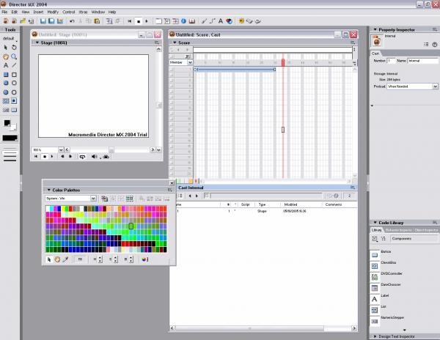

Features of Director:

Powerful: Author once and deliver content anywhere, on and offline.

Object Inspector with data browser functionality: Inspect all properties of script instances, and examine the hierarchy of elements inside of 3D cast members and Macromedia Flash MX sprites. Quick examination and modification of all your movies’ components reduces both debugging and development time.

Unified script and debugging window: work more efficiently and with less screen clutter using the new script and debugging window. The script window switches to debugging mode when a breakpoint is encountered. Scripts remain in the debugging window even after you stop debugging them. Now you can debug, browse and edit scripts all in the same window, even while debugging.

Colour-coding of recently changed variables: Track changes quickly and easily. As you step through your code, the Debugging window displays in red the variables whose values have changed. This gives you immediate visual feedback.

Split-paned message window (input and output panes): Movies can execute and display information in the output pane while you enter and execute Lingo commands in the input pane. This lets you immediately see the result of your code changes.

New script window buttons :

- Line numbering
- Auto colouring
- Auto formatting
- Alphabetical 3D Lingo
- Categorized 3D Lingo
- Scripting Xtras

New massage window buttons :
- Alphabetical 3D Lingo
- Categorized 3D Lingo
- Scripting Xtras
- Watch expression
- Inspect object
- Clear

Save development time with new message window buttons such as :

- Clear button. This time saving button clears the output pane with one touch.
- Watch expression and inspect object buttons. These let you quickly place object and variable into the watcher pane of the debugging window and the object inspector.

New quick time 6 xtra
Integrated
Import macromedia flash mx files
Macromedia flash mx launch and edit
Lingo control over macromedia flash mx objects
Macromedia flash mx objects from scripting
Speech Xtra
Accessible
Accessibility support

Practical no.2

Aim: Design and develop multimedia presentation.

PowerPoint can be wonderful multimedia tool used to aid an excellent presentation. However, presentation can be very good or very poor. It is up to make the difference. We have developed some guideline that we think will make you presentation readable, captivating and successful.

Guidelines for your PowerPoint Presentation

- General
- Templates
- Fort and Fort size
- Background ,Charts and Tables
- Saving your presentation

General: do’s & don’t

- Don’t read the text off your PowerPoint slides. If it is readable your audience will read it. If it is not than you should not include it in your presentation.
- Don’t use animations or sound effects unless they are crucial to your presentation. These things are a distraction to your audience.
- Keep your slide transitions simple and consistent.
- Don’t pack too much information onto a slide, In PowerPoint, less is more.
- Don’t use too many images on a slide. Your audience will spend more time looking at them than listing to you.
- Generally, you should have no more than 6 words per line, and no more than 6 lines per slides.
- Keep in mind that you are the presenter and PowerPoint is your visual aid.
- Slides that look great on your computer screen may not as good projected on to a screen or in video / web converted presentations.
- Do come early as possible, to make sure the equipment and your presentation are working well in the room the presentations is given.

Templates:

- When creating slides, it is often easier to develop them using PowerPoint, even if they are not presented as a PowerPoint presentation.
- The PowerPoint templates provide you with a model for creating text in appropriate format for video or web transmission.
- The PowerPoint templates generally default to font sizes that are more appropriate for video or web transmission.
- Set the template default to landscape format which is appropriate for video or web transmission.
- PowerPoint slide templates are in the Auto layout option of PowerPoint program.
- The most common type of text slides used in lectures is called the “Bulleted list”.
- Including an all black slide at the end of presentation is a nice way to avoid the distraction of unrelated text on screen during the question and answer period.

Fonts and Font Sizes:

- Use font sizes in the range of 28 to 32 points. Anything smaller may not be readable from the back of the room.
- We recommend 32 point fonts, because this size is most appropriate for video or web transmission.
- We recommend san serif forts like Arial or because they are easier to read on a power point slide. Fonts like times new roman may look nice on your monitor, but when your slide is being projected more than 20 feet, the text on the slide will appear blurry.
- Use a combination of upper and lower case. The combination generally makes it easier to read than all upper case.
- If all your data won’t fit on a slide at 28 point. Either condense your data or create another slide.
- Don’t use more than one font per slide.
- In general, when it comes to fonts, bigger is better.
- Font colors should be in the range of whites to yellow for dark backgrounds and black to dark blue for light backgrounds. Never us red. It doesn’t project well and may agitate your audience.

Background, Charts and Table:

- Colours on your slide will appear much lighter when projected. Take notice, lighter does not mean brighter. Find a colour scheme that works and stick to it.
- Use a solid background colour, like medium blue. Stay away from dark green and reds. They don’t project as well, and red can agitate your audience.
- Stay away from the gradient backgrounds. If you feel you must have them, make sure your text is in contrast with all of the gradation. Keep your gradation in range from black to medium dark colors.
- On dark backgrounds, we suggest your font colours to range from white to yellow.
- Light backgrounds are acceptable provided the lettering is dark enough. Use only dark blue or black. We do not recommend light backgrounds because the slides become more difficult to read during video or web transmission. Compare watching a television image with a white background and a dark background.
- Yellow backgrounds are acceptable only with black fonts.

Saving your presentation:

- While you are developing your PowerPoint slides, save your presentations often.
- Click through the slides of your presentation, and make sure everything is how you want it before you’re save your project.
- A good rule of thumbs is to observe your presentation at a distance; this will let you know if your slides can be seen from the back of the room.
- If your presentation is not to large, email it to yourself. You will always have access to if in case something happens to the media it was originally saved on.
- If your presentation is small enough, save it on a least two different diskettes.
- For larger presentation we recommend saving it on the computer you are going to use for the presentation, on a recordable CD, or PowerPoint packaging wizard. Zip disk are also acceptable, bare in mind, most computer do not have zip drivers.
- Test run your presentation on a different machine, to make sure everything was saved correctly.
- If possible test run your presentation with the computer in room the presentation will take place.

EXAMPLE OF PROJECT



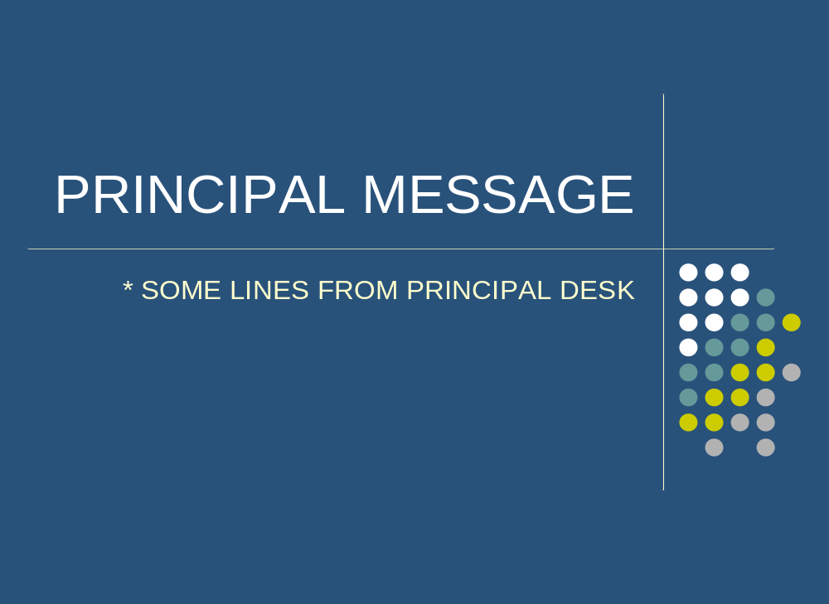
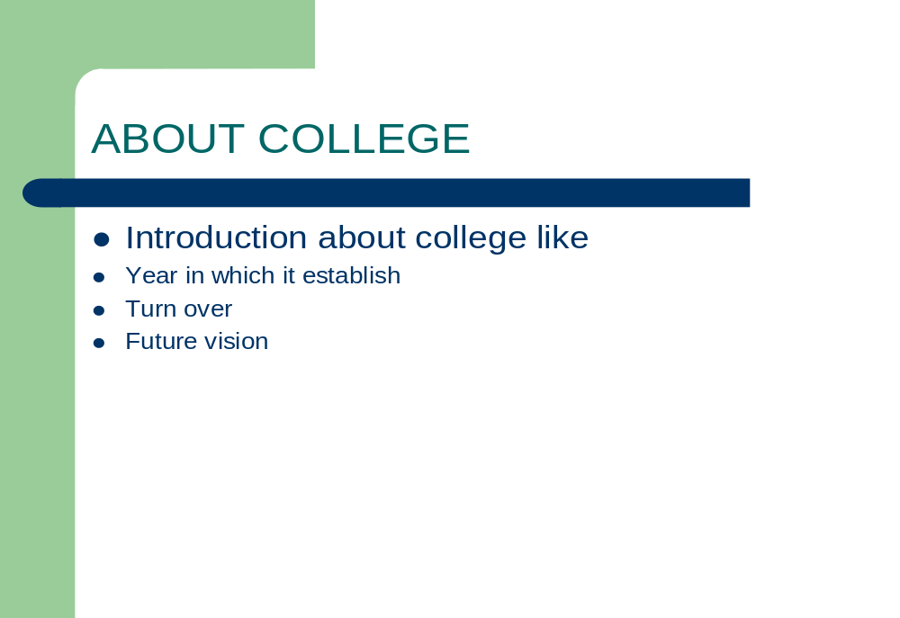

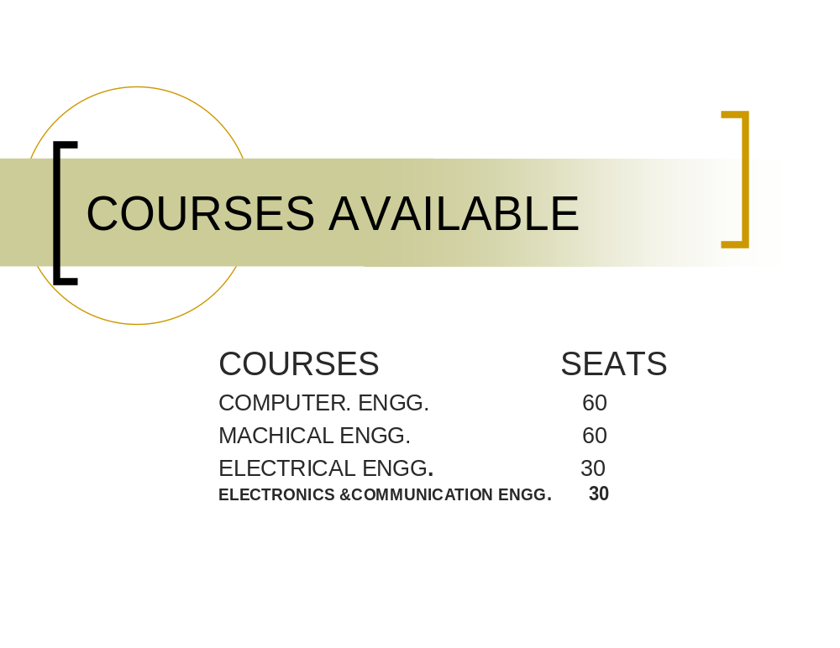

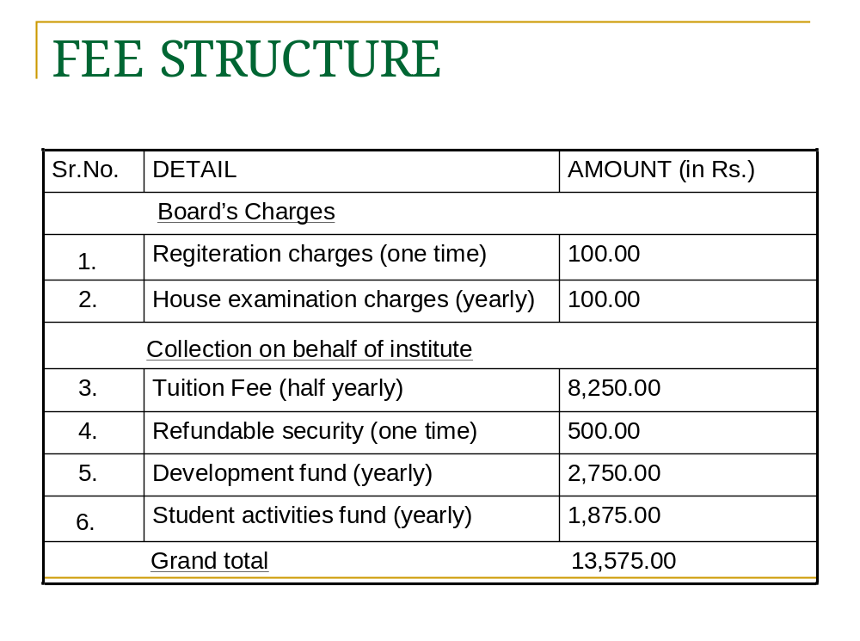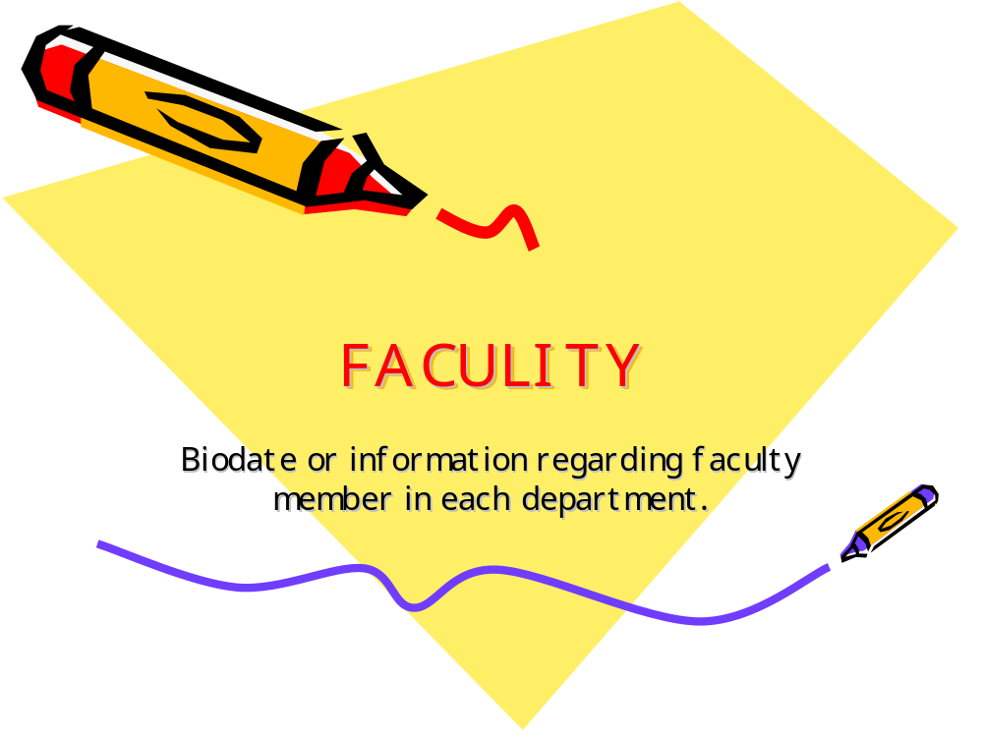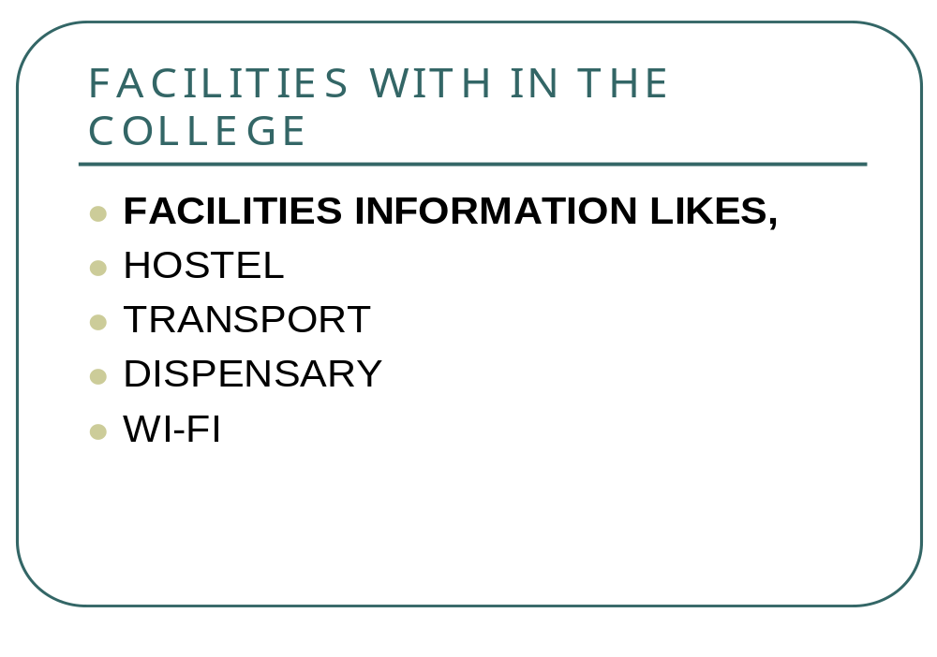

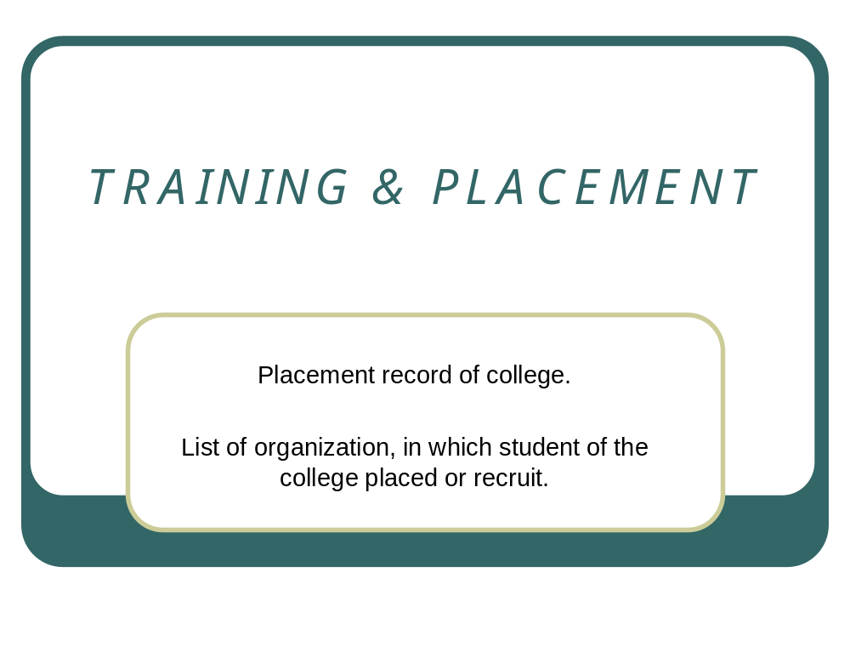

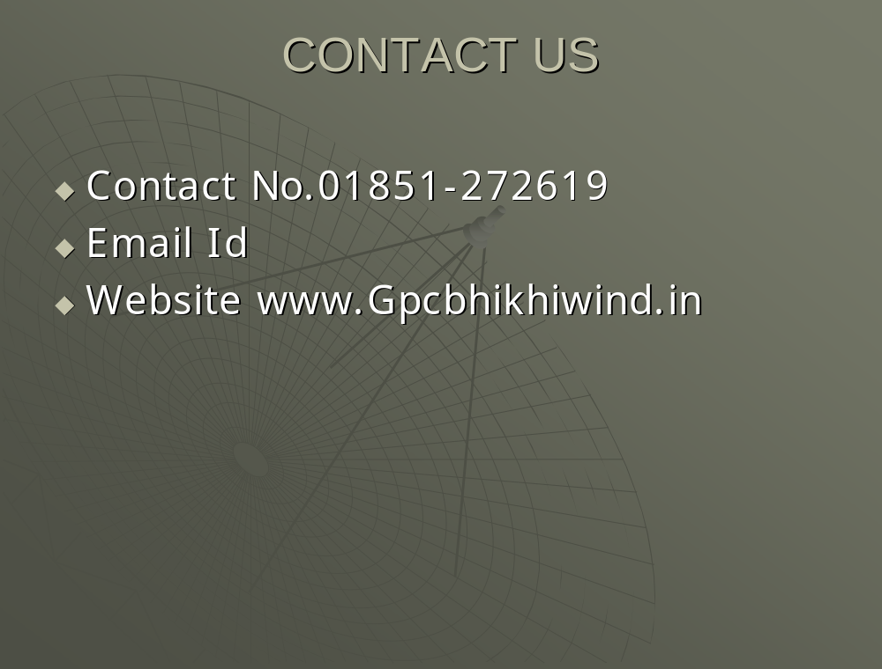

PRACTICAL NO.3

AIM: Design and develop multimedia lessons useful.

Presentation here provides you the introduction to multimedia. It is designed in power point with the of various features it provides. Sample of multimedia lesson given following:

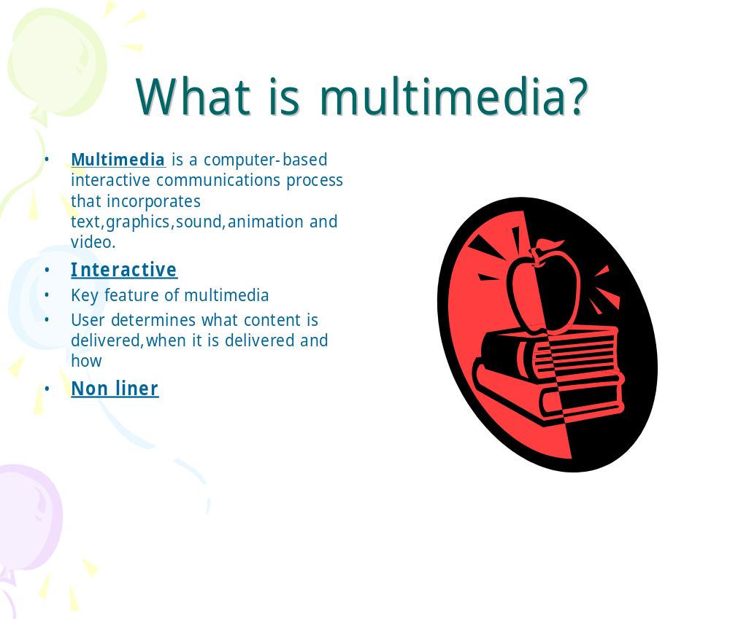

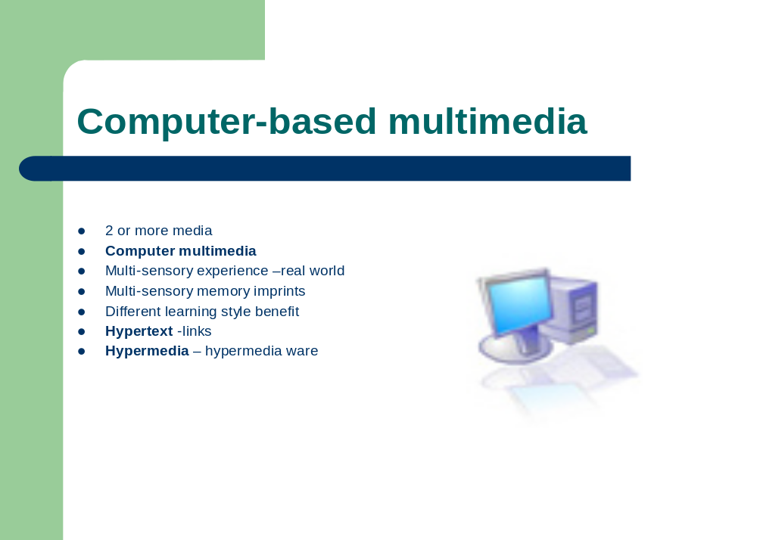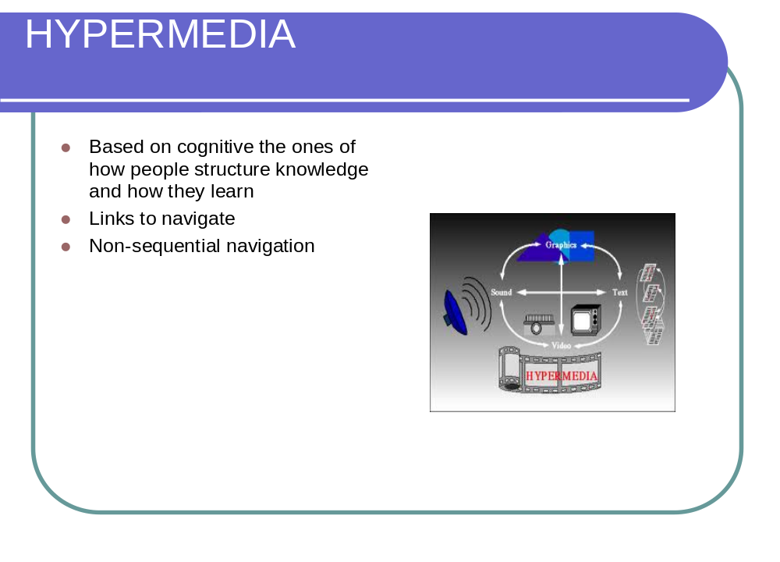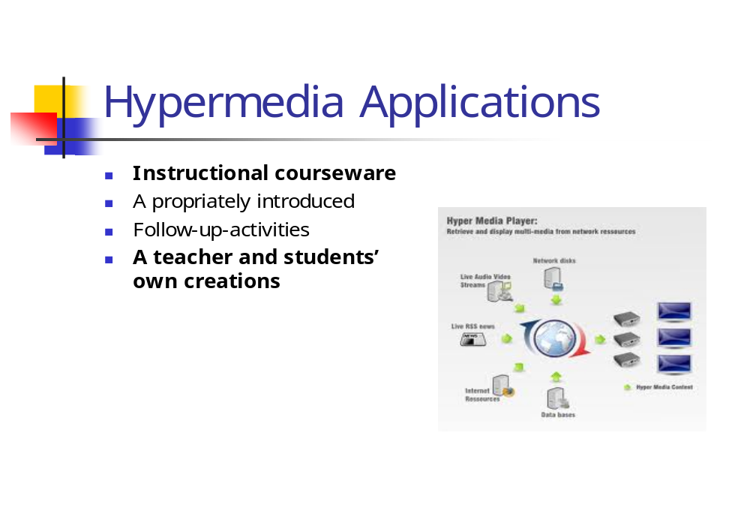

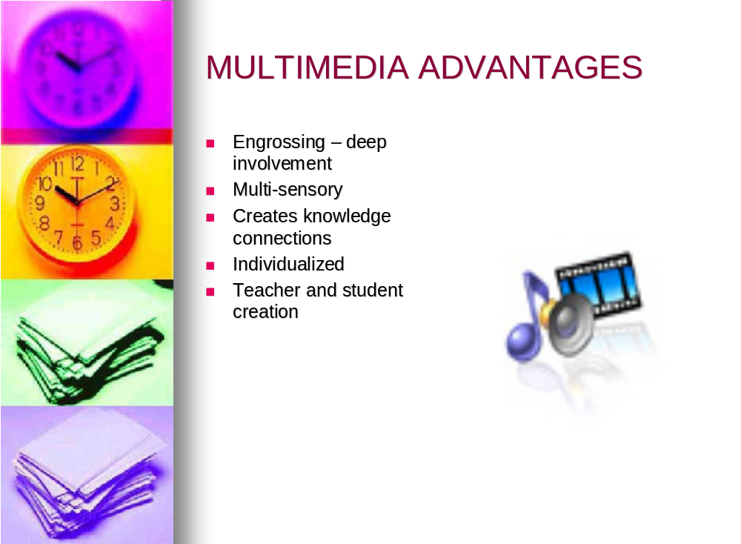

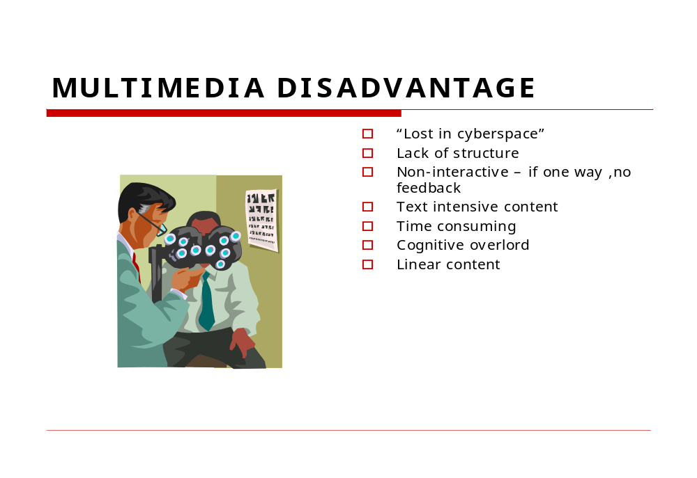

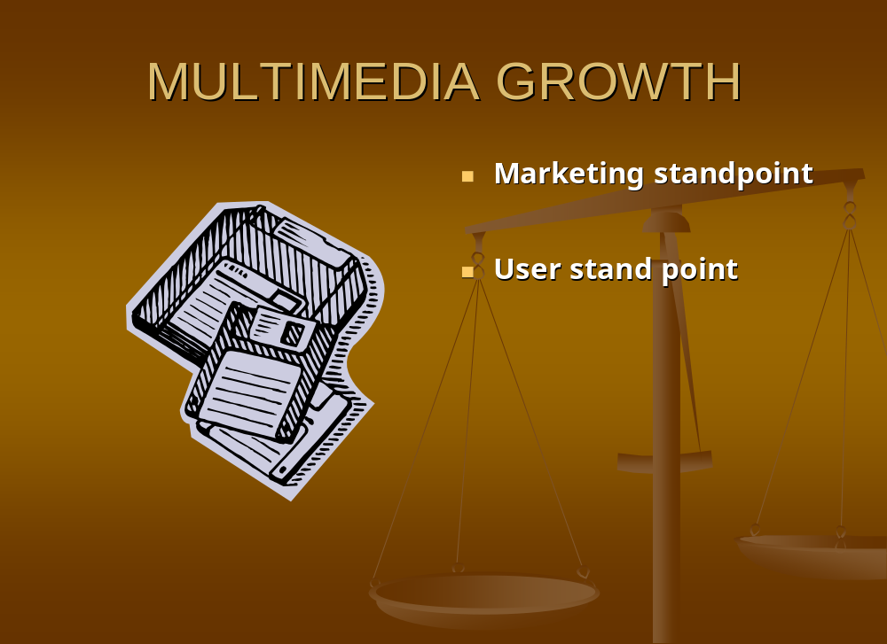
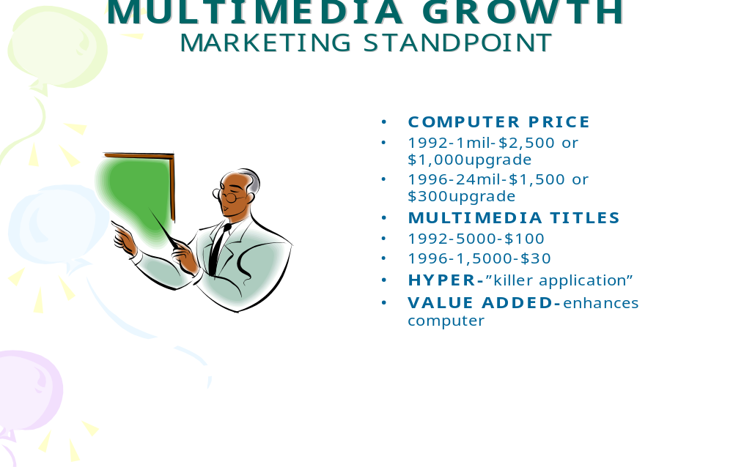

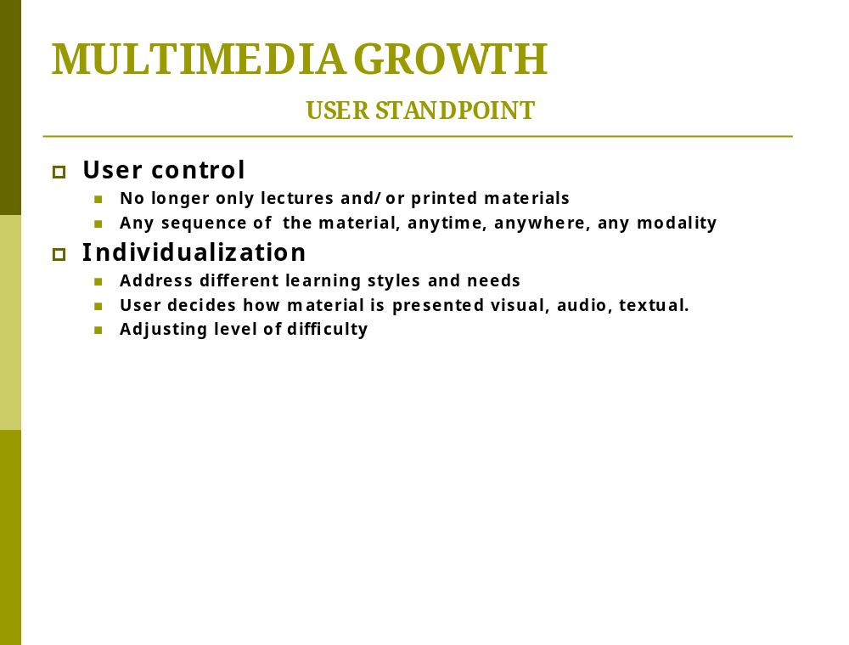
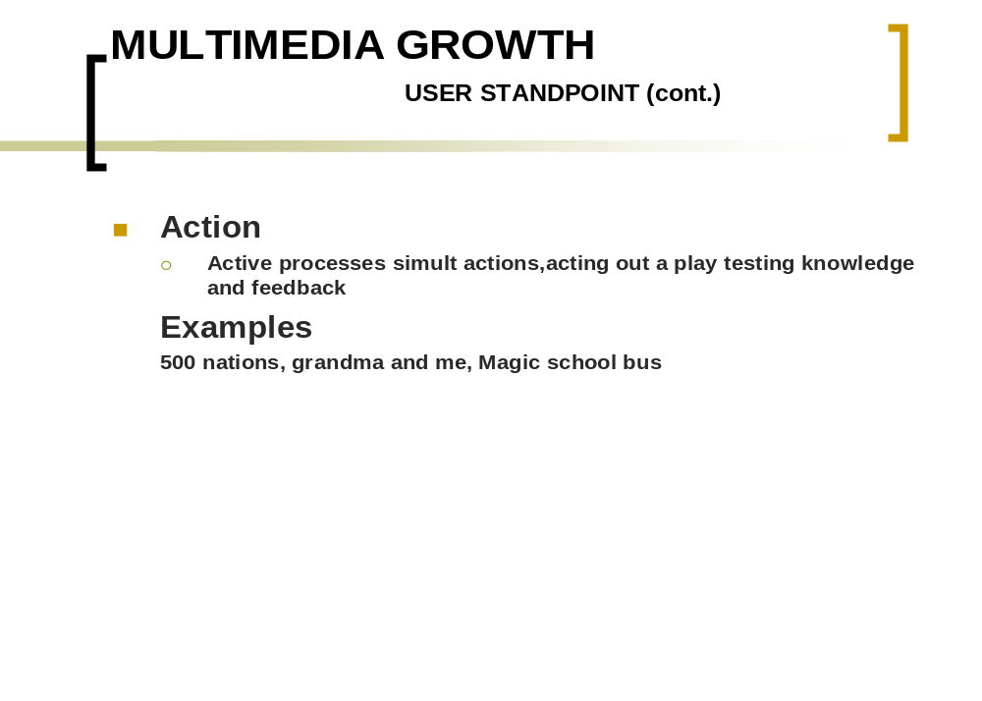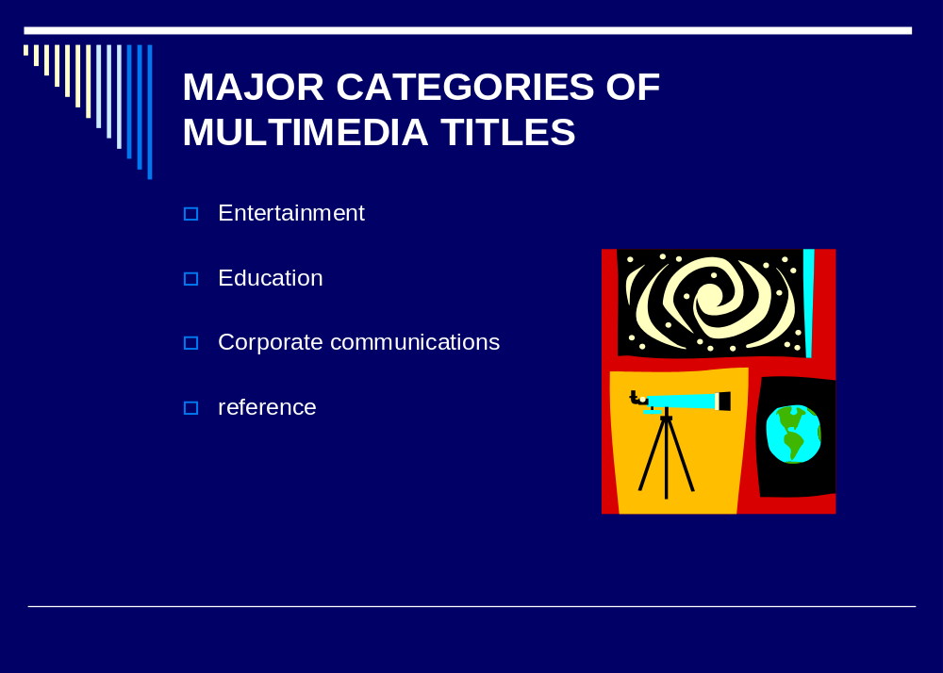
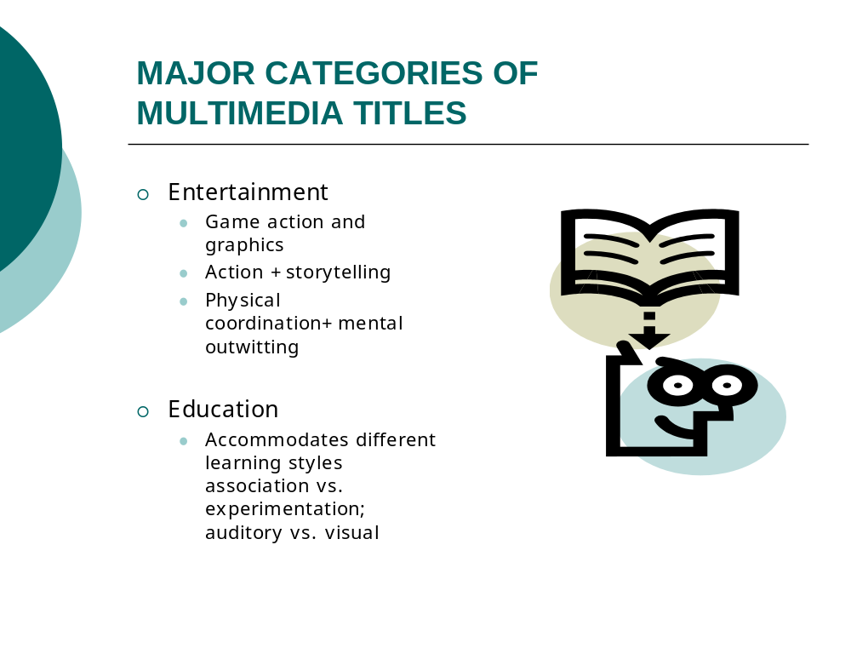

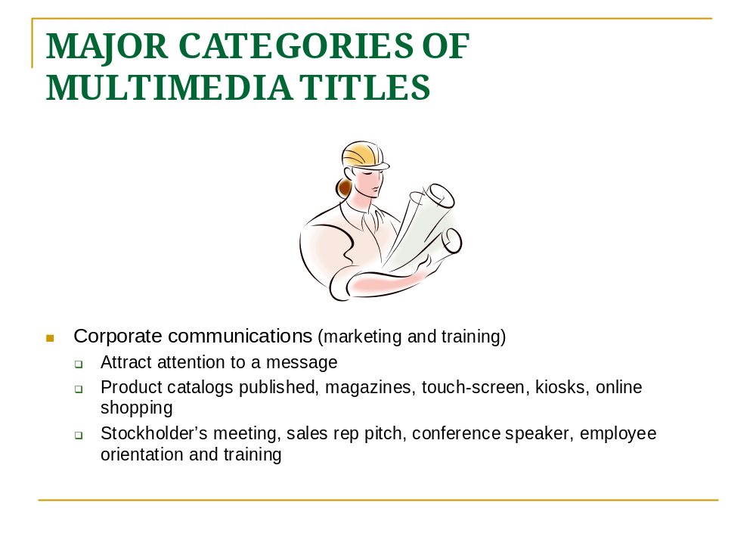
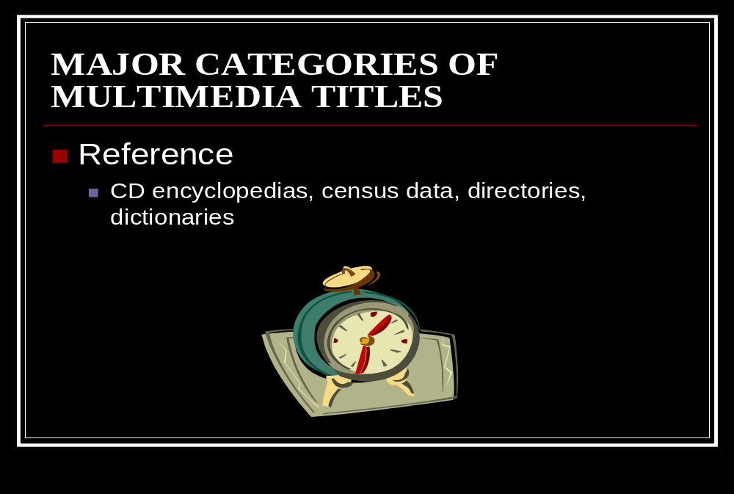
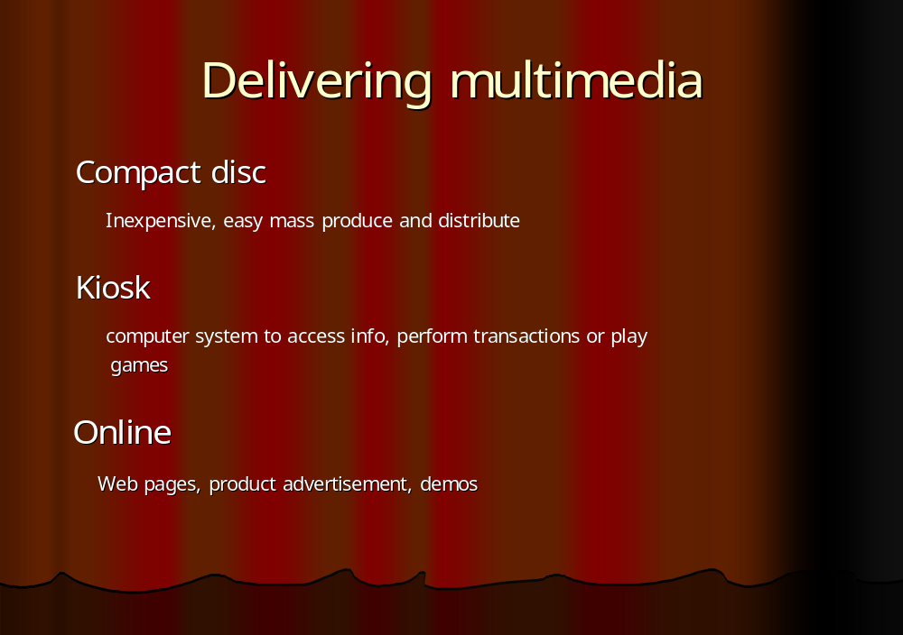



Practical no. 4

Aim: design some interactive multimedia applications.

In this practical, it shows how the basics of tweening works in Director. We are going to create a ball shape, and make it bounce. Start off by creating a new project, and change the template size to something large enough to work with. Choose Modify →Movie →Properties, I used 500*300

Now let’s make our ball. Choose Insert→Media Element→Vector Shape

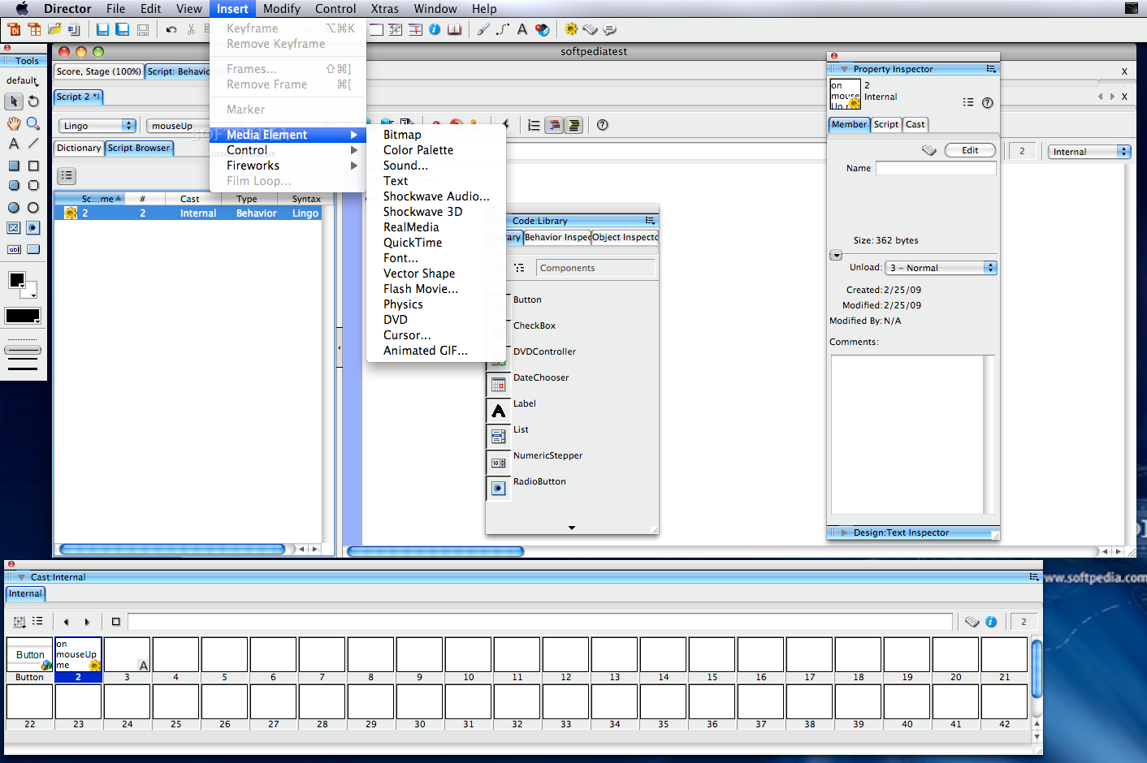
Click on the filled ellipse tools, and hold down and drag your cursor in the new window to make a shape that suits you.

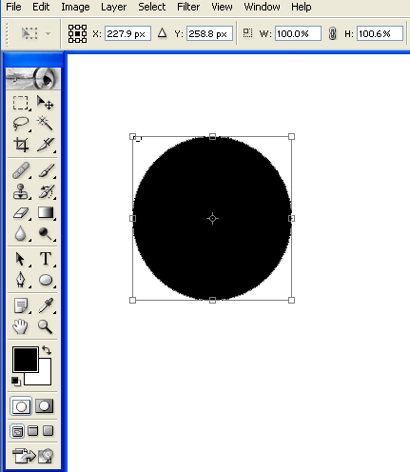

Change the mode to gradient by click on the gradient button.

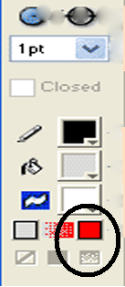

Change the coloured boxes above the gradient button to whatever you like. These determine two colours used in your gradient.

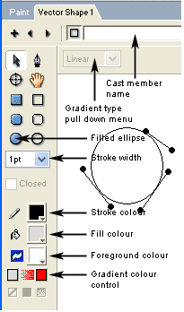
We are making ball, so lets change the gradient mode. Click on the dropdown menu and choose “Radial.”
Give your ball a name, by typing it in the form towards the top of your window, and click on the box shape to the left to drag your shape onto your animation stage.

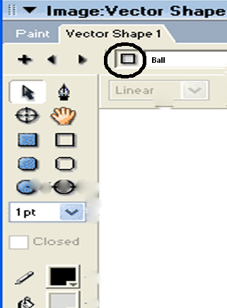

Place the ball towards the bottom left.

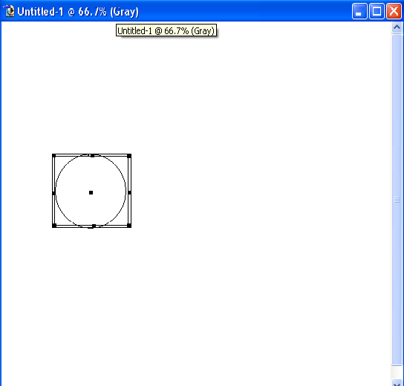

Take a look at your “score” window. This is much like flash timeline. The numbers moving horizontally across the window represent the amount of frames in your animation. The default is 30.

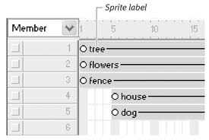
We are going to add key frames to this timeline. By creating key frames you can dictate exactly where you want your ball to be at that particular frame. Using tweening, the frames in between will fill in accordingly. Click on the tenth frame on your score, and choose insert → key frame.

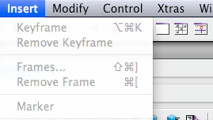
While on your tenth frame, click back into your stage window, and move your ball upwards and towards the right.

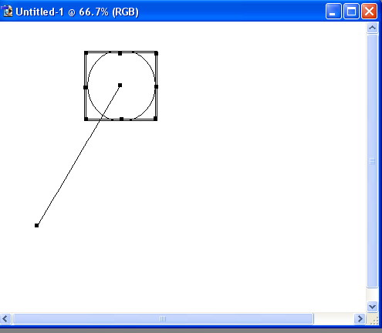
Create another key frame and frame 20, and move your ball downwards and towards the right.

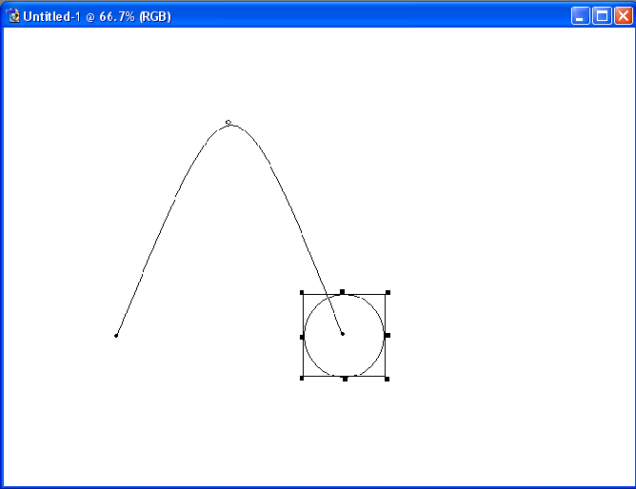

Create one last key frame at frame 30, and move your ball upwards and towards the right.

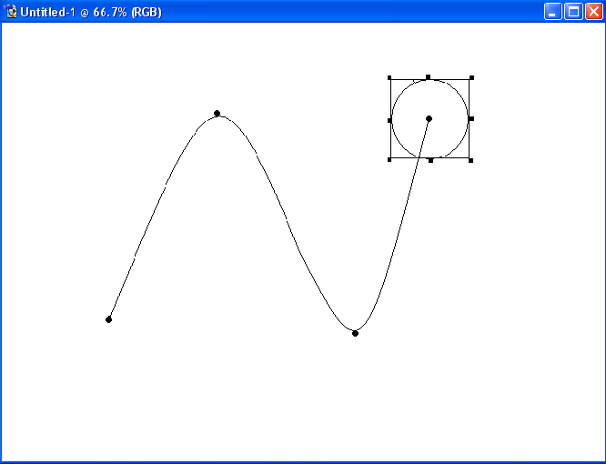

Now click on play button to run the application.

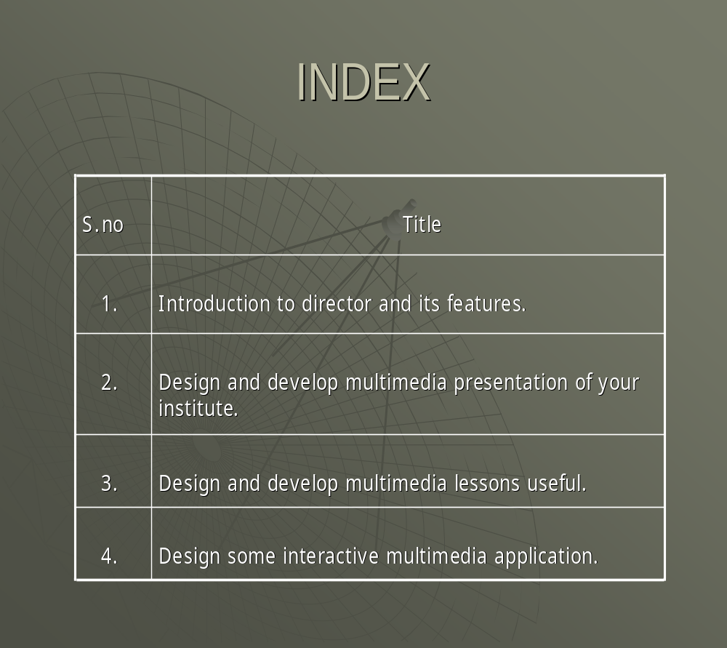

GOVT POLYTECHNIC COLLEGE BHIKHIWIND(TARN TARAN)


PRACTICAL FILE

OF

MULTIMEDIA SYSTEM DESIGN

COMPUTER ENGINEERING

IN

5th SEMESTER

SUBMITTED TO: SUBMITTED BY:
ER. AMARJIT SINGH INDERBIR SINGH
Reg.No.6026

